UNIT 2

What is Numerical Control Machine?
- READING COMPREHENSION

What is Numerical Control Machine?

What is Numerical Control Machine?
Numerical control, popularly known as the NC is very commonly used in the machine tools. Numerical control is defined as the form of programmable automation, in which the process is controlled by the number, letters, and symbols. In case of the machine tools this programmable automation is used for the operation of the machines.

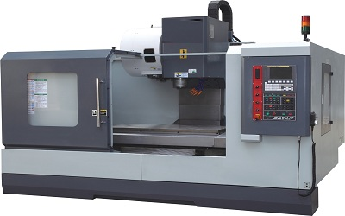

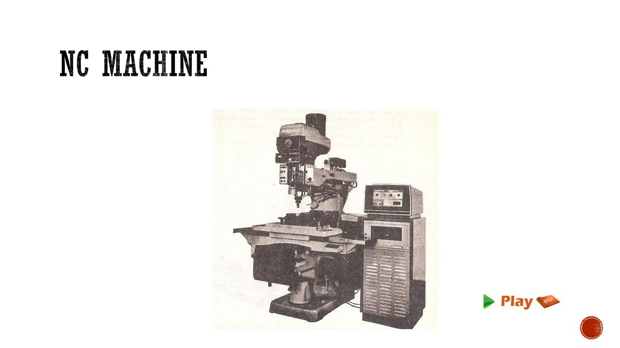

In other words, the numerical control machine is defined as the machined that is controlled by the set of instructions called as the program. In numerical control method the numbers form the basic program instructions for different types of jobs; hence the name numerical control is given to this type of programming. When the type of job changes, the program instructions of the job also change. It is easier to write the new instructions for each job, hence NC provides lots of flexibility in its use.
The NC technology can be applied to wide variety of operations like drafting, assembly, inspection, sheet metal working, etc. But it is more prominently used for various metal machining processes like turning, drilling, milling, shaping etc. Due to NC all the machining operations can be performed at the fast rate resulting in bulk manufacturing becoming quite cheaper.

Brief History of the NC
The invention of numerical control has been due to the pioneering works of John T. Parsons in the year 1940, when he tried to generate a curve automatically by milling cutters by providing coordinate motions. In the late 1940s Parsons conceived the method of using punched cards containing coordinate position system to control a machine tool. The machine directed to move in small increments and generate the desired finish. In the year, 1948, Parons demonstrated this concept to the US Air Force, who sponsored the series of project at laboratories of Massachusetts Institute of Technology (MIT). After lots of research MIT was able to demonstrate first NC prototype in the year 1952 and in the next year they were able to prove the potential applications of the NC.
Soon the machine tool manufacturers began their own efforts to introduce commercial NC units in the market. Meanwhile, the research continued as MIT, who were able to discover Automatically Programmed Tools, known as APT language that could be used for programming the NC machines. The main aim of APT language was to provide the means to the programmer by which they can communicate the machining instructions to the machine tools in easier manner using English like statements. The APT language is still used in widely in the manufacturing industry and a number of modern programming languages are based on the concepts of APT.

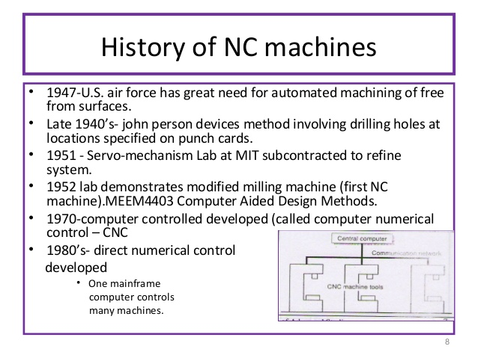

UNDERSTANDING THE PASSAGE
Task 1. Answer the following questions
  - What is in case of the machine tools this programmable automation used for ?
…………………………………………………………………………………
…………………………………………………………………………………
  - Can The NC technology be applied to wide variety of operations? What are they?
…………………………………………………………………………………
…………………………………………………………………………………
  - When has the invention of numerical control been due to the pioneering works of John T. Parsons ?
…………………………………………………………………………………
…………………………………………………………………………………
  - What is APT the short form for ?
…………………………………………………………………………………
…………………………………………………………………………………
  - What are a number of modern programming languages based on ?

…………………………………………………………………………………
…………………………………………………………………………………

Task 2. Are these sentences true or false? Correct the false sentences.
- The numerical control machine is defined as the machined that is controlled by the set of instructions called as the program..
…………………………………………………………………………………
….………………………………………………………………………………
- When the type of job changes, the program instructions of the job also don’t change. . .
…………………………………………………………………………………
….………………………………………………………………………………
- Due to NC all the machining operations can be performed at the fast rate resulting in bulk manufacturing becoming more expensive.

…………………………………………………………………………………
….………………………………………………………………………………
- In the late 1950s Parsons conceived the method of using punched cards containing coordinate position system to control a machine tool..
…………………………………………………………………………………
….………………………………………………………………………………
- APT language could be used for programming the NC machines
.
…………………………………………………………………………………
….………………………………………………………………………………

Task 3. Choose the best answer
- In numerical control method the numbers form the basic program instructions for different types of-------------.
  - languages B. jobs C. computers D. machines
- It is easier to write the ------------instructions for each job, hence NC provides lots of flexibility in its use.
.
  - old B. soft C. new D. hard
- The invention of numerical control has been due to the pioneering works of---------.
  - Johnny Hallyday B. Emmanuel Marcon C. John T.Parsons D. Viadimir Putin
- In the year 1952 and in the next year they were able to prove the potential -------- of the NC.

  - applications B. novels
C. measurement D. news
- The machine tool manufacturers began their own efforts to introduce commercial NC units ------------ .
  - On the way B. in the market
C. in the sky D. at laboratories

VOCABULARY
Define (v)
Symbol (n)
the set of
method (n)
hence
provide (v)
apply (v)
application (n)
drafting
assembly
inspection
sheet metal working
prominently
turning
drilling
milling
shaping
perform (v) = carry out
rate
bulk
invent (v)
invention (n)
to generate
curve (n)
cutter (n)
coordinate
motion (n)
direct (v)
increment (n)
sponsore (v)
research (n)
NC prototype
demonstrate (v) : prove chứng minh
potential (a)
project (n)
series of : hàng loạt, hang loại

